**Functional design**

|  |  |
| --- | --- |
| **Project:** | Fischer technik |
| **Client:** | ROC TER AA |
| **Projectnumber:** | 1 |
| **Auteur:** | Jeremey van Uden |
| **Date:** | 25/04/2018 |
| **Version:** | 1 |

Name Client: Name Contractor:

Date: Date:

Signature Client: Signature Contractor:

Inhoud

PROJECT MANAGEMENT 2

PROJECT DETAILS 2

PROJECT DESCRIPTION 2

REQUIREMENTS 2

CONTENT OF A REQUIREMENTS DOCUMENT 3

USE CASE DIAGRAM AND SCENARIOS 3

WIREFRAMES 4

PERSISTENT DATA 4

APPENDICES 5

APPENDICE A 5

# PROJECT MANAGEMENT

**Members:**

* Jeremey van Uden
  + Research
  + Back end
  + Documentation
* Jesse Siersema
  + Project Manager
  + GUI
  + Back end
  + Documentation

**Communcation:**

* Discord
* Whatsapp
* Vocal

**Meeting:**

* Every morning at arrival

# PROJECT DETAILS

**Name of Project:**

* Fisher Technik

**Name of Client**

* ROC TER AA

**Name of Contractor:**

* Doki Doki Coding Club

# PROJECT DESCRIPTION

Workflow:

* Every morning a meeting
* Work on project when possible
* Do Research when you have nothing to do

**Intention of The Project:**

* Working automated warehouse bay

# MoSCoW(requirements)

|  |  |  |  |
| --- | --- | --- | --- |
| Must | Should | Could | Won’t |
| Moving arm | Check if boxes are empty | Website control | Break the components |
| Stock rescan | Return Box | If no production organize racks | Cause any harm |
| HMI(Human machine interface)C# |  |  |  |
| Place on conveyer belt |  |  |  |
| Pick up from conveyer belt |  |  |  |
| Manual/Automatic stock checking |  |  |  |
| Testing Inputs/Outputs |  |  |  |

# 

# USE CASE DIAGRAM AND SCENARIOS

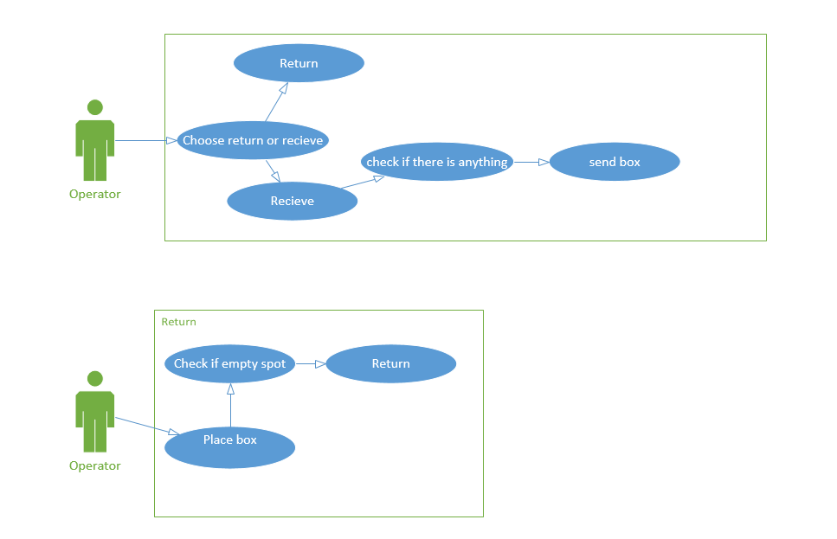

# Wireframes:

# **Selection to send back or recieve**

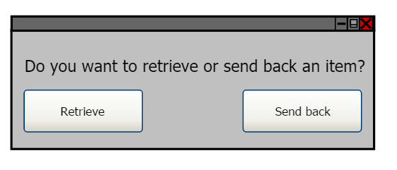

# **Position selection for sending back and retrieving objects**

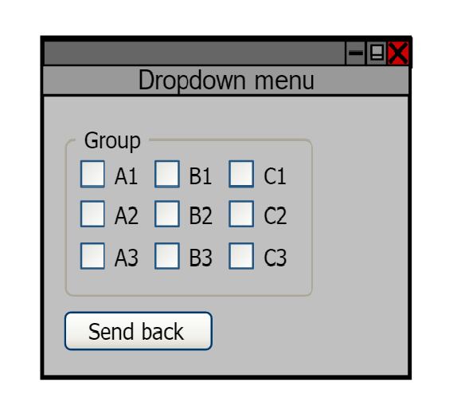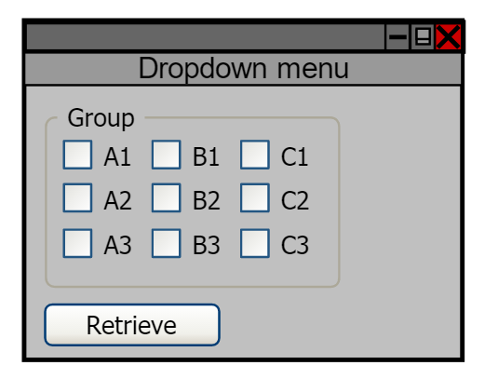

# **Inside selection**

